Chapter 14, Problem 79.

Refer to the network in Fig. 14.96.

(a) Find Z_{in}(s).

(b) Scale the elements by K_{m} =10 and K_{f} = 100. Find Z_{in}(s) and ω₀.

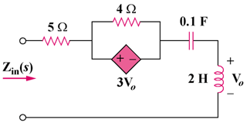

Figure 14.96
For Prob. 14.79.

